Laura Marie (Waguespack) Boudreaux
June 26, 1917 – October 2, 2005

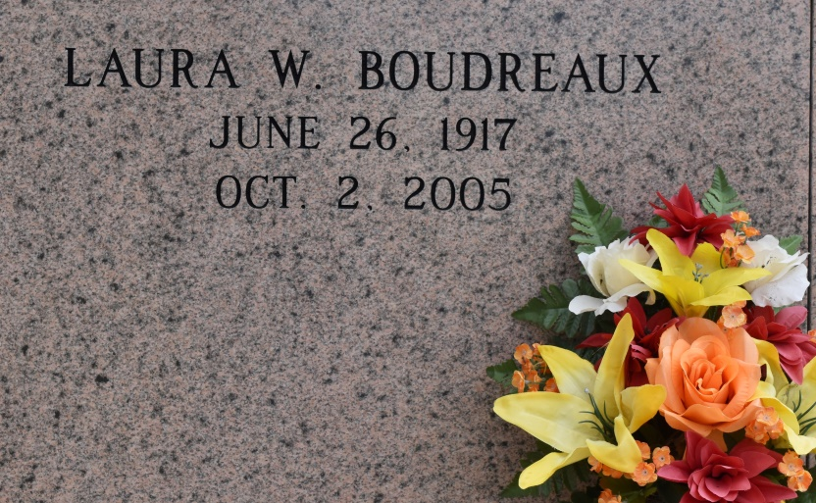

A loving wife, mother, grandmother and great-grandmother and a homemaker, she died in Baton Rouge. She was 88, a resident of Convent and a native of Donaldsonville.
She is survived by four daughters and two sons-in-law, Tilda and Doug Bourgeois, Gonzales, Janelle Seaton, Convent, and Darlene and Ryan Waguespack and Debra Clouatre, all of Gonzales; four sons and daughters-in-law, Jerry and Phyllis Boudreaux, Newell "Bubby" and Susan Boudreaux, Dwayne "Beanie" and Priscilla Boudreaux, and Gayle and Denise Boudreaux, all of Gonzales; daughter-in-law, Vera Boudreaux, Gonzales; four sisters, Althea Dupuy, Lacombe, Inez Hinchman, Norco, Virgie Navo, Baton Rouge, and Madeline Melancon, Lumberton, Miss.; three brothers, Emile Waguespack, Harahan, Hubert Waguespack, Ponchatoula, and Leroy Waguespack, LaPlace; 21 grandchildren and 18 great-grandchildren.
She was preceded in death by her husband, Newell Roy Boudreaux; parents, Emile and Mathilda Schexnaydre Waguespack; son, Melvin Boudreaux; two sisters, Marguerite Pekich and Ruth Dornier; and three brothers, Daniel, Melvin and Ronald Waguespack.
Pallbearers will be her grandsons. She was a member of St. Mary's Altar Society. Special thanks to the staff of Heritage Manor of Baton Rouge and Life Source Hospice of Baton Rouge.
Unknown source
*****
A loving wife, mother, grandmother and great-grandmother and a homemaker, she died at 1:45 a.m. Sunday, Oct. 2, 2005, in Baton Rouge. She was 88, a resident of Convent and a native of Donaldsonville. Entombment in St. Mary's Chapel Mausoleum, Union.
She is survived by four daughters and two sons-in-law, Tilda and Doug Bourgeois, Gonzales, Janelle Seaton, Convent, and Darlene and Ryan Waguespack and Debra Clouatre, all of Gonzales; four sons and daughters-in-law, Jerry and Phyllis Boudreaux, Newell "Bubby" and Susan Boudreaux, Dwayne "Beanie" and Priscilla Boudreaux, and Gayle and Denise Boudreaux, all of Gonzales; daughter-in-law, Vera Boudreaux, Gonzales; four sisters, Althea Dupuy, Lacombe, Inez Hinchman, Norco, Virgie Navo, Baton Rouge, and Madeline Melancon, Lumberton, Miss.; three brothers, Emile Waguespack, Harahan, Hubert Waguespack, Ponchatoula, and Leroy Waguespack, LaPlace; 21 grandchildren and 18 great-grandchildren.
She was preceded in death by her husband, Newell Roy Boudreaux; parents, Emile and Mathilda Schexnaydre Waguespack; son, Melvin Boudreaux; two sisters, Marguerite Pekich and Ruth Dornier; and three brothers, Daniel, Melvin and Ronald Waguespack. Pallbearers were her grandsons. She was a member of St. Mary's Altar Society.
Gonzales Weekly Citizen (Ascension Parish, LA) - Thursday, October 6, 2005
Contributed by Jane Edson

